Do’s and don’ts:

* Adding the user who containing the e-mail which are not in Approved Domain
* Or removing the domain which need to be approved by org admin before the user get access

* Keep under control the number of custom fields .

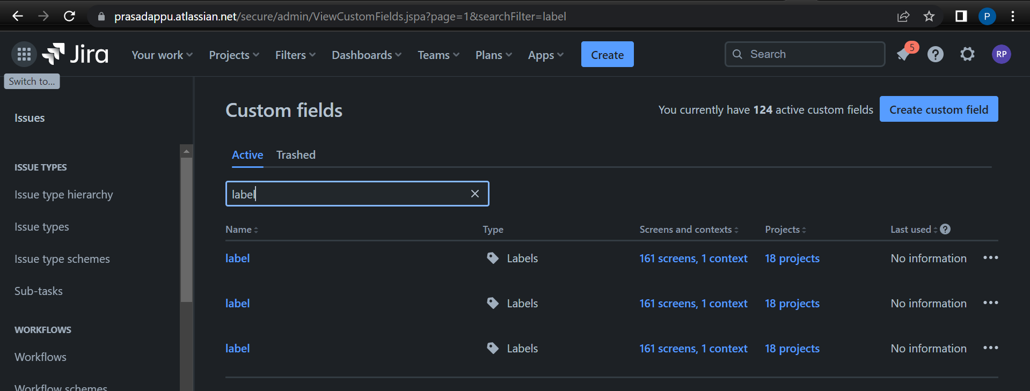

* using third party source or improper(not secured) commands in the backend

